**Web-based Ordering & Ingredient Estimating for Bakery Manufacturer**

Software Requirement Specification

By

**Miss. Nontra Mahachanont 542115026**

**Mr. Parinya Panyanak 542115034**

Department of Software Engineering

College of Arts, Media and Technology

Chiang Mai University

Project Advisor

\_\_\_\_\_\_\_\_\_\_\_\_\_\_\_\_\_\_\_\_\_\_\_\_

**Mr.Phudinan Singkhamfu**

|  |  |  |
| --- | --- | --- |
| **Software Requirement Specification** | | |
| Cross Ref. VSE-29110 | **Coverage Level:** | **Version:** |
|  | V.1.0 | V.1.0 |

|  |  |
| --- | --- |
| **Process Ownership** | **Approving Authority** |
| Web-based Ordering & Ingredient Estimating for Bakery Manufacturer | Aj.Phudinan Singkhamfu |
| **Scope** | **Approved Date** |
| Senior Project | 9 June 2014 |

|  |  |  |  |  |
| --- | --- | --- | --- | --- |
| **Version Number** | **Record Date** | **Prepared/**  **Modified By** | **Reviewed By** | **Change Details** |
| **Documents History** | | | | |
| V.0.1 | 06-05-2014 | NM, PP | NM, PP | - Add Chapter 1 |
| V.0.2 | 07-05-2014 | NM, PP | NM, PP | - Add Chapter 2  - Add Chapter 3  - Fix inappropriate words |
| V.0.4 | 09-05-2014 | NM, PP | NM, PP | - Add Chapter 4  - Add Chapter 5  - Fix inappropriate words |
| V.0.6 | 12-05-2014 | NM, PP | NM, PP | - Adjust Chapter 4  - Adjust Chapter 5  - Adjust Product Features  - Fix inappropriate words |
| V.0.9 | 24-05-2014 | NM, PP | NM, PP | - Adjust Chapter 5  - Fix inappropriate words |
| V.1.0 | 27-05-2014 | NM, PP | NM, PP | - Adjust Product Features  - Adjust Chapter 3  - Adjust Chapter 4  - Adjust Chapter 5  - Fix inappropriate words |

**\*NM = Nontra Mahachanont**

**\*PP = Parinya Panyanak**

**\*PS = Phudinan Singkhamfu**

**Table of contents**

[**Chapter One | Introduction** 4](#_Toc388823436)

[1.1 Objection 4](#_Toc388823437)

[1.2 Intended Audience and Reading Suggestions 4](#_Toc388823438)

[1.3 Project Scope 4](#_Toc388823439)

[**Chapter Two | Overall Description** 5](#_Toc388823440)

[2.1 Product Perspective 5](#_Toc388823441)

[2.2 Product Features 5](#_Toc388823442)

[2.3 User Classes and Characteristics 5](#_Toc388823443)

[2.4 Operation Environment 5](#_Toc388823444)

[2.5 Design and Implementation Constraints 6](#_Toc388823445)

[**Chapter Three | User Requirements** 7](#_Toc388823446)

[**Chapter Four | System Features** 8](#_Toc388823447)

[4.1 Software Requirement Specification 8](#_Toc388823448)

[**Chapter Five | Specific Requirement** 13](#_Toc388823449)

[5.1 Use Case Scenarios 13](#_Toc388823450)

[5.2 Use Case Description 14](#_Toc388823451)

[5.3 Use Case Specification 19](#_Toc388823452)

# **Chapter One | Introduction**

## 1.1 Objective

* To help manufacturer estimate ingredients and control usage.
* To support the manufacturer can cooperation.
* To control document of the manufacturer easily.
* To support wholesaler ordering conveniently.

## 1.2 Intended Audience and Reading Suggestions

This Software Requirement Specification was created for everyone that involves with the Web-based Ordering & Ingredient Estimating for Bakery Manufacturer. It will make benefits for people as following

**Development Team**

**-** Convenient to make strategies and planning process.

**-** Control and guarantee qualities of the system to make it right according to the standard.

**-** Check the customer requirement for makes sure that everyone has the same understand and avoid the fault of the work.

**-** In testing system, tester will verify the system work correctly without any problem.

**Customer**

**-** Help customer to understand about quality and limitation of this system.

**-** Checking the requirement of the customer and the system are the same.

## 

## 1.3 Project Scope

Web-based Ordering & Ingredient Estimating for Bakery Manufacturer is a management system that helps the admin to manage ordering information and estimate ingredient usage. Then the system also helps the wholesaler to manage order and record ordered history. The project focuses on implementation of general order management system.

# **Chapter Two | Overall Description**

## Product Perspective

Web-based Ordering & Ingredient Estimating for Bakery Manufacturer has two main sections which are Admin section and Wholesaler section. This system can help admin and wholesaler for convenient to order bakery product and check ordered information. System can help for keeping ordered history and make a summary report.

## Product Features

Main features of Web-based Ordering & Ingredients Estimating for Bakery Manufacturer will be following

**Feature 1: Member Management System**

* Member registration feature
* User authentication feature
* Member information page
* Manage member information

**Feature 2: Product Management System**

* Bakery product information page
* Manage bakery product information

## 2.3 User Classes and Characteristics

Intended users for this project are people of admin permission to make an order of bakery product and officer that can involve knowing information.

## 

## 2.4 Operation Environment

Firefox Version 29.0 or Later

## 2.5 Design and Implementation Constraints

**Design**

Provide web application for easy to use. Design for easy to understand. The user who not have skill able to buy bakery product from the website.

**Constraints**

- Only member can access the web application.

- Require internet connection.

# **Chapter Three | User Requirements**

* **URS-01:** Admin can register to activate member to access the application by

create new member information; username, password, first name, last name, phone number, address, user type and profile picture into database.

* **URS-02:** Admin and wholesaler authenticate the web application account.
* **URS-03:** Admin can manage all member information; username, password, first

name, last name, phone number, address, user type and profile picture in the database.

* **URS-04:** Wholesaler can update own information; username, password, first

name, last name, phone number, address, user type and profile picture in the database.

* **URS-05:** Admin can manage all bakery product information; bakery product ID,

bakery product name, information, price, category and product picture in the database.

* **URS-06:** Wholesaler can view all bakery product information by search keyword

of bakery product ID, bakery product name, information, price, category and product picture in the database.

# **Chapter Four | System Features**

## 4.1 Software Requirement Specification

**URS-01:** Admin can register to activate member to access the application by create new member information; username, password, first name, last name, phone number, address, user type and profile picture into database.

**SRS-01:** The system can connect to the database**.**

**SRS-02:** The system shall provide a link for register new member information within member management page interface.

**SRS-03:** The system shall provide a registration form within a creating new member page interface to admin input member information.

**SRS-04:** The system shall provide service for validation input information.

**SRS-05:** The system shall provide notification to display a message after submitting a registration form.

**SRS-06:** The system shall provide service to store information into the database.

**SRS-07:** The system shall provide a user interface to display the new member information.

**URS-02:** Admin and wholesaler authenticate the web application account.

**SRS-01:** The system can connect to the database.

**SRS-08:** The system shall provide a link for logging in to the web application.

**SRS-09:** The system shall provide a login form within user interface to admin and wholesaler login users as a different role.

**SRS-10:** The system can hide the characters in the password field.

**SRS-04:** The system shall provide service for validation input information.

**SRS-11:** The system shall provide notification to display a message after authenticates.

**SRS-12:** The system can take wholesaler or admin to the index page of their user type.

**SRS-13:** The system shall provide a link for logging out from the web application.

**SRS-14:** The system shall provide confirmation dialog box.

**URS-03:** Admin can manage all member information; username, password, first

name, last name, phone number, address, user type and profile picture in the database.

**SRS-01:** The system can connect to the database.

**SRS-15:** The system shall provide a textbox within member management interface to search the member information.

**SRS-16:** The system shall provide a user interface to display list of member. In each label shall display member name text and profile picture on member list.

**SRS-17:** The system shall provide a user interface to display the old member information which are username, first name, last name, phone number, address, user type and profile picture on view information of member management page.

**SRS-18:** The system shall provide a link for update member information within the member management interface.

**SRS-19:** The system shall provide a member form within updating member information page interface to user update new member information.

**SRS-20:** The system shall provide confirmation button.

**SRS-04:** The system shall provide service for validation input information.

**SRS-21:** The system shall provide service to update member information into the database.

**SRS-07:** The system shall provide a user interface to display the new member information.

**SRS-22:** The system shall provide a link for delete member information within the member management interface.

**SRS-14:** The system shall provide confirmation dialog box.

**SRS-23:** The system shall provide service to delete member information into the database.

**SRS-24:** The system shall provide service to get new member information to display in member management interface.

**URS-04:** Wholesaler can update own information; username, password, first

name, last name, phone number, address, user type and profile picture in the database.

**SRS-01:** The system can connect to the database.

**SRS-17:** The system shall provide a user interface to display the old member information which are username, first name, last name, phone number, address, user type and profile picture on view information of member management page.

**SRS-18:** The system shall provide a link for update member information within the member management interface.

**SRS-19:** The system shall provide a member form within updating member information page interface to user update new member information.

**SRS-20:** The system shall provide confirmation button.

**SRS-04:** The system shall provide service for validation input information.

**SRS-21:** The system shall provide service to update member information into the database.

**SRS-07:** The system shall provide a user interface to display the new member information.

**URS-05:** Admin can manage all bakery product information; bakery product ID, bakery product name, description, price, category and product picture in the database.

**SRS-01:** The system can connect to the database.

**SRS-25:** The system shall provide a link for creating new bakery product information within the bakery product interface.

**SRS-26:** The system shall provide a bakery product form within a creating new bakery product information page interface to admin input bakery product information.

**SRS-04:** The system shall provide service for validation input information.

**SRS-27:** The system shall provide notification to display a message after submitting bakery product form.

**SRS-06:** The system shall provide service to store information into the database.

**SRS-28:** The system shall provide a textbox within bakery product interface to search the bakery product information.

**SRS-29:** The system shall provide a user interface to display all list of bakery product. In each label shall display bakery product name text and bakery product picture on bakery product list.

**SRS-30:** The system shall provide a user interface to display the old bakery product information which are bakery product ID, bakery product name, product description, product price, product category and product picture on view information of bakery product page.

**SRS-31:** The system shall provide a link for update bakery product information within the bakery product interface.

**SRS-32:** The system shall provide a bakery product form within updating bakery product information page interface to admin update new bakery product information.

**SRS-33:** The system shall provide service to update bakery product information into the database.

**SRS-34:** The system shall provide a user interface to display the new bakery product information.

**SRS-35:** The system shall provide service to get new bakery product information to display in bakery product interface.

**SRS-36:** The system shall provide a link for delete bakery product information within the bakery product interface.

**SRS-14:** The system shall provide confirmation dialog box.

**SRS-37:** The system shall provide service to delete bakery product information into the database

**URS-06:** Wholesaler can view all bakery product information by search keyword

of bakery product ID, bakery product name, information, price, category and product picture in the database.

**SRS-01:** The system can connect to the database.

**SRS-28:** The system shall provide a textbox within bakery product interface to search the bakery product information.

**SRS-04:** The system shall provide service for validation input information.

**SRS-29:** The system shall provide a user interface to display all list of bakery product. In each label shall display bakery product name text and bakery product picture on bakery product list.

**SRS-30:** The system shall provide a user interface to display the old bakery product information which are bakery product ID, bakery product name, product description, product price, product category and product picture on view information of bakery product page.

# 

# **Chapter Five | Specific Requirement**

## 5.1 Use Case Scenarios

**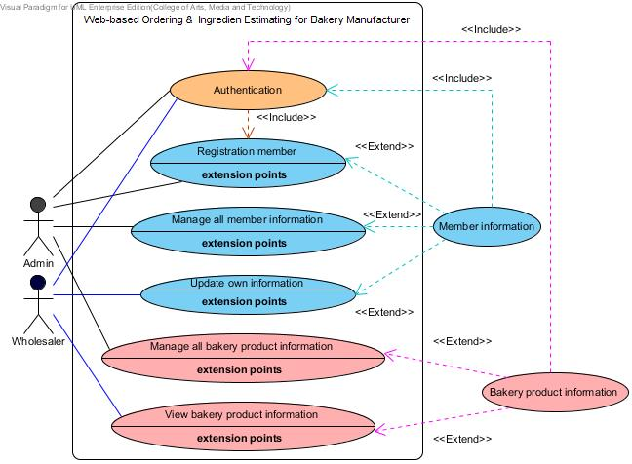**

**Figure 1: Use case diagram that show activity of Admin and Wholesaler**

## 

## 5.2 Use Case Description

**User Case:** Registration member

|  |  |
| --- | --- |
| **Use Case ID:** | UC – 01 |
| **Use Case Name:** | Registration member |
| **Actors:** | Admin |
| **Short Description:** | This use case allows admin can activate member by register them to the website. |
| **Preconditions:** | Admin have login to the website. |
| **Post conditions:** | Member will use username and password to login to the website. |
| **Normal Flow:** | 1. Request a registration link within member management page.  2. Input username, password, first name, last name, phone number, address, user type and profile picture into registration form.  3. Click “Submit” button.  4. System shall checks validation from input information.  5. System shall display successful of registration to user.  6. System shall collect information of registration to the database. (username, password, first name, last name, phone number, address, user type and profile picture)  7. System shall display new member information to user. |
| **Alternative and Exceptional:** | 3a. In step 3 of the normal flow.  If the input invalid type of information.  3.1 System displays the error message to user.  3.2 System shall request the command from user input again.  3b. In step 3 of the normal flow.  If the input valid type of information.  3.1 Use case resumes on step 5 of normal flow.  3c. In step 3 of the normal flow.  If the input information is duplicate.  3.1 System displays the error message to user.  3.2 System shall request the command from user input again.  3d. In step 3 of the normal flow.  If the input information is not duplicate.  3.1 Use case resumes on step 5 of normal flow. |

**User Case:** Authentication

|  |  |
| --- | --- |
| **Use Case ID:** | UC – 02 |
| **Use Case Name:** | Authentication |
| **Actors:** | Admin and Wholesaler |
| **Short Description:** | This use case allows admin and wholesaler login to the system and logout from the system. |
| **Preconditions:** | Users have username and password. |
| **Post conditions:** | User can login, use service and logout from the website. |
| **Normal Flow:** | 1. System shall display login page.  2. Input correctly username and password.  3. Click “Login” button.  4. System shall verify username and password from the database.  5. System shall collect sign in information to the database.  6. System shall display login successful message to user.  7. Then user can login to the web application and can use the service of this application.  8. Click “Logout” button.  9. System shall back to login page. |
| **Alternative and Exceptional:** | 3a.In step 3 of the normal flow.  If the input valid username and password.  3.1 Use case resumes on step 5 of normal flow.  3b.In step 3 of the normal flow.  If the input invalid username or password.  3.1 System displays the error message to user.  3.2 System shall request the command from user input again. |

**User Case:** Manage all member information

|  |  |
| --- | --- |
| **Use Case ID:** | UC – 03 |
| **Use Case Name:** | Manage all member information |
| **Actors:** | Admin |
| **Short Description:** | This use case allows admin can manages all member information. The admin can update member information and delete member in the system. |
| **Preconditions:** | Admin have login to the website and member information has been created. |
| **Post conditions:** | Admin can update member information and delete member into the database. |
| **Normal Flow:** | 1. Request member management page.  2. Search the member information in the web application.  3. System shall request list of member from the database.  4. Select a label from list of member to display member information.  5. Select update information or delete member functions.  6. Click “Save” button.  7. System shall validation input information.  8. System shall display successful message to user.  9. System shall collect new information to the database.  10. System shall display new member information to user. |
| **Alternative and Exceptional:** | 2a. In step 2 of the normal flow.  If the input invalid with information in database.  2.1 System displays the not found message to user.  2.2 System shall request the command from user input again.  2b. In step 2 of the normal flow.  If the input valid with information in database.  2.1 Use case resume on step 3 of normal flow.  5a. In step 5 of the normal flow.  If the admin click update information.  5.1 System validates input information before update in the database.  5.2 Use case resume on step 6 of normal flow.  5b. In step 5 of the normal flow.  If the admin click delete member.  5.1 Use case resume on step 6 of normal flow. |

**User Case:** Update own information

|  |  |
| --- | --- |
| **Use Case ID:** | UC – 04 |
| **Use Case Name:** | Update own information |
| **Actors:** | Wholesaler |
| **Short Description:** | This use case allows wholesaler update own information in the system. |
| **Preconditions:** | Users have login to the website and member information has been created. |
| **Post conditions:** | User can update own information and save new information into the database. |
| **Normal Flow:** | 1. Request member management page.  2. Click “Update information” button.  3. Input new information.  4. Click “Save” button.  5. System shall validation input information.  6. System shall display successful message update information to user.  7. System shall collect new information to the database.  8. System shall display new member information to user. |
| **Alternative and Exceptional:** | 5a. In step 5 of the normal flow.  If the input invalid type of information.  5.1 System displays the error message to user.  5.2 System shall request the command from user input again.  5b. In step 5 of the normal flow.  If the input valid type of information.  5.1 Use case resume on step 6 of normal flow. |

**User Case:** Manage bakery product information

|  |  |
| --- | --- |
| **Use Case ID:** | UC – 05 |
| **Use Case Name:** | Manage bakery product information |
| **Actors:** | Admin |
| **Short Description:** | This use case allows admin can manages bakery product information. The admin can add, update and delete member information in the system. |
| **Preconditions:** | Admin have login to the website. |
| **Post conditions:** | Admin can manage bakery product information and save new information into the database. |
| **Normal Flow:** | 1. Request bakery product information page.  2. Search the bakery product information in the web application.  3. System shall validation keyword from the database.  4. System shall request list of bakery product from the database.  5. Select a label from list of bakery product to display bakery product information.  6. Select create, update or delete bakery product functions.  7. Input new information of bakery product.  8. Click “Save” button.  9. System shall validation input information.  10. System shall display successful message to user.  11. System shall collect new information to the database.  12. System shall display new bakery product information to user. |
| **Alternative and Exceptional:** | 3a. In step 3 of the normal flow.  If the input valid with information in database.  3.1 Use case resume on step 4 of normal flow.  3b. In step 3 of the normal flow.  If the input invalid with information in database.  3.1 System displays the not found message to user.  3.2 System shall request the command from user input again.  6a. In step 6 of the normal flow.  If the admin click create new bakery product information.  6.1 System validates input information before add in the database.  6.2 Use case resume on step 7 of normal flow.  6b. In step 6 of the normal flow.  If the admin click update bakery product information.  6.1 System validates input information before add in the database.  6.2 Use case resume on step 7 of normal flow.  6c. In step 6 of the normal flow.  If the admin click delete bakery product.  6.1 Use case resume on step 8 of normal flow. |

**User Case:** View bakery product information

|  |  |
| --- | --- |
| **Use Case ID:** | UC – 06 |
| **Use Case Name:** | View bakery product information |
| **Actors:** | Admin and Wholesaler |
| **Short Description:** | This use case allows admin and wholesaler view bakery product information in the system. |
| **Preconditions:** | Users have login to the website. |
| **Post conditions:** | User can know bakery product information into the database. |
| **Normal Flow:** | 1. Request bakery product information page.  2. Search the bakery product information in the web application.  3. System shall validation keyword from the database.  4. System shall request list of bakery product from the database.  5. Select a label from list of bakery product.  6. System shall request information of bakery product from the database. |
| **Alternative and Exceptional:** | 3a. In step 3 of the normal flow.  If the input valid with information in database.  3.1 Use case resume on step 4 of normal flow.  3b. In step 3 of the normal flow.  If the input invalid with information in database.  3.1 System displays the not found message to user.  3.2 System shall request the command from user input again. |

## 

## 5.3 Use Case Specification

**URS-01:** Admin can use registration to activate member to access the application.

**Precondition:** The admin must login to the system.

**Input:**

|  |  |  |
| --- | --- | --- |
| **Name** | **Description** | **Example** |
| First name | Only alphabet is allowed. No special character can be used. The length should not over 20 characters. | “Nontra” |
| Last name | Only alphabet is allowed. No special character can be used. The length should not over 20 characters. | “Mahachanont” |
| Username | Username should be the e-mail format. | “nontra@gmail.com” |
| Password | Password must be 4-20 characters and contain the small letter, capital letter, and number. | aWefk2343 |
| Phone number | The number which length is exact 10 digits | “0812345678” |
| Address | Address unlimited characters and contain the small letter, capital letter, and number. | “House No.197 Chroenrat Road, Watgate sub-district, Mueng Chiang Mai district, Chiang Mai province, 5000, Thailand” |
| User type | Specification role of user. (Admin and Wholesaler) | Admin |
| Profile picture | The profile picture type of file must be JPEG image. The size of picture is unlimited. | vcm_s_kf_m160_155x160.jpg  Me.jpg |

**Action:**

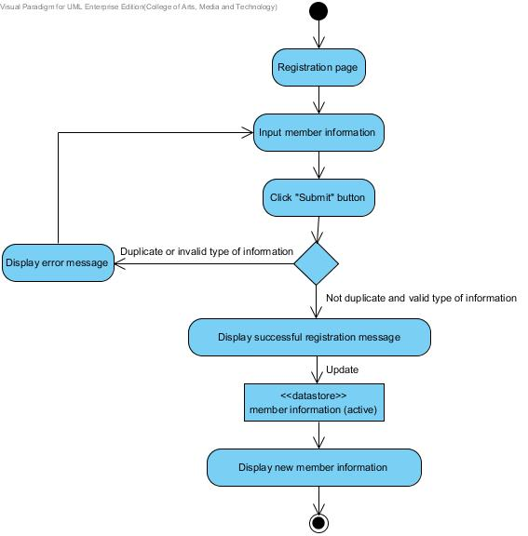

**Figure 2: AD-01 Admin registration to active member**

**Output:** All information of member will record to the database and member will get username and password to login to the website.

**System Requirement Specification:**

**SRS-01:** The system can connect to the database**.**

**SRS-02:** The system shall provide a link for register new member information within member management page interface.

**SRS-03:** The system shall provide a registration form within a creating new member page interface to admin input member information.

**SRS-04:** The system shall provide service for validation input information.

**SRS-05:** The system shall provide notification to display a message after submitting a registration form.

**SRS-06:** The system shall provide service to store information into the database.

**SRS-07:** The system shall provide a user interface to display the new member information.

**URS-02:** Admin and wholesaler authenticate the web application account.

**Precondition:** The admin and wholesaler must have username and password before login to the system.

**Input:**

|  |  |  |
| --- | --- | --- |
| **Name** | **Description** | **Example** |
| Username | Username should be the e-mail format. | “nontra@gmail.com” |
| Password | Password must be 4-20 characters and contain the small letter, capital letter, and number. | aWefk2343 |

**Action:**

**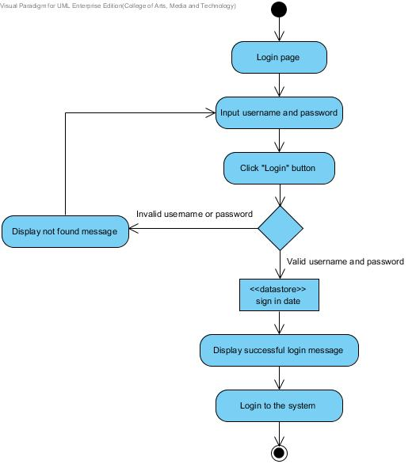**

**Figure 3: AD-02 Admin and wholesaler login to the system**

**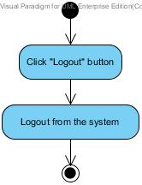**

**Figure 4: AD-03 Admin and wholesaler logout from the system**

**Output:** User can login to the website and logout from the website.

**System Requirement Specification:**

**SRS-01:** The system can connect to the database.

**SRS-08:** The system shall provide a link for logging in to the web application.

**SRS-09:** The system shall provide a login form within user interface to admin and wholesaler login users as a different role.

**SRS-10:** The system can hide the characters in the password field.

**SRS-04:** The system shall provide service for validation input information.

**SRS-11:** The system shall provide notification to display a message after authenticates.

**SRS-12:** The system can take wholesaler or admin to the index page of their user type.

**SRS-13:** The system shall provide a link for logging out from the web application.

**SRS-14:** The system shall provide confirmation dialog box.

**URS-03:** Admin can manage all member information; username, password, first name, last name, phone number, address, user type and profile picture in the database.

**Precondition:** The admin must have login to the system and member information has been created.

**Input:**

|  |  |  |
| --- | --- | --- |
| **Name** | **Description** | **Example** |
| First name | Only alphabet is allowed. No special character can be used. The length should not over 20 characters. | “Nontra” |
| Last name | Only alphabet is allowed. No special character can be used. The length should not over 20 characters. | “Mahachanont” |
| Username | Username should be the e-mail format. | “nontra@gmail.com” |
| Password | Password must be 4-20 characters and contain the small letter, capital letter, and number. | aWefk2343 |
| Phone number | The number which length is exact 10 digits | “0812345678” |
| Address | Address unlimited characters and contain the small letter, capital letter, and number. | “House No.197 Chroenrat Road, Watgate sub-district, Mueng Chiang Mai district, Chiang Mai province, 5000, Thailand” |
| User type | Specification role of user. (Admin and Wholesaler) | Admin |
| Profile picture | The profile picture type of file must be JPEG image. The size of picture is unlimited. | vcm_s_kf_m160_155x160.jpg  Me.jpg |

**Action:**

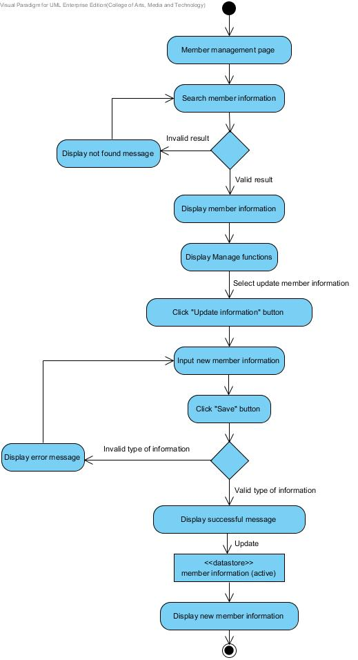

**Figure 5: AD-04 Admin update member information**

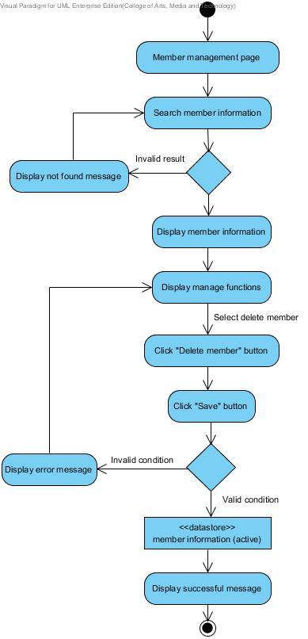

**Figure 6: AD-05 Admin delete member information**

**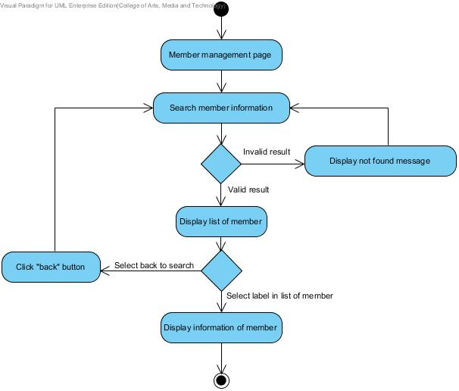**

**Figure 7: AD-07 Admin view member information**

**Output:** All information of member will record to the database. On the other hands admin fill incorrect information, the system will not record.

**System Requirement Specification:**

**SRS-01:** The system can connect to the database.

**SRS-15:** The system shall provide a textbox within member management interface to search the member information.

**SRS-16:** The system shall provide a user interface to display list of member. In each label shall display member name text and profile picture on member list.

**SRS-17:** The system shall provide a user interface to display the old member information which are username, first name, last name, phone number, address, user type and profile picture on view information of member management page.

**SRS-18:** The system shall provide a link for update member information within the member management interface.

**SRS-19:** The system shall provide a member form within updating member information page interface to user update new member information.

**SRS-20:** The system shall provide confirmation button.

**SRS-04:** The system shall provide service for validation input information.

**SRS-21:** The system shall provide service to update member information into the database.

**SRS-07:** The system shall provide a user interface to display the new member information.

**SRS-22:** The system shall provide a link for delete member information within the member management interface.

**SRS-14:** The system shall provide confirmation dialog box.

**SRS-23:** The system shall provide service to delete member information into the database.

**SRS-24:** The system shall provide service to get new member information to display in member management interface.

**URS-04:** Wholesaler can update own information; username, password, first

name, last name, phone number, address, user type and profile picture in the database.

**Precondition:** The wholesaler must have login to the system and member information has been created.

**Input:**

|  |  |  |
| --- | --- | --- |
| **Name** | **Description** | **Example** |
| First name | Only alphabet is allowed. No special character can be used. The length should not over 20 characters. | “Nontra” |
| Last name | Only alphabet is allowed. No special character can be used. The length should not over 20 characters. | “Mahachanont” |
| Username | Username should be the e-mail format. | “nontra@gmail.com” |
| Password | Password must be 4-20 characters and contain the small letter, capital letter, and number. | aWefk2343 |
| Phone number | The number which length is exact 10 digits | “0812345678” |
| Address | Address unlimited characters and contain the small letter, capital letter, and number. | “House No.197 Chroenrat Road, Watgate sub-district, Mueng Chiang Mai district, Chiang Mai province, 5000, Thailand” |
| User type | Specification role of user. (Admin and Wholesaler) | Admin |
| Profile picture | The profile picture type of file must be JPEG image. The size of picture is unlimited. | vcm_s_kf_m160_155x160.jpg  Me.jpg |

**Action:**

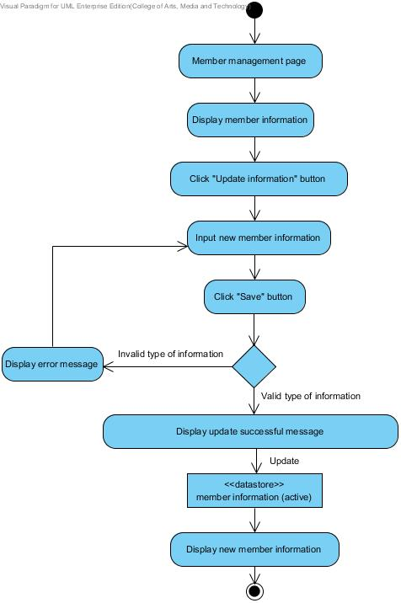

**Figure 8: AD-06 Wholesaler update own information**

**Output:** All information of member will record to the database. On the other hands, if wholesalers fill incorrect information, the system will not record.

**System Requirement Specification:**

**SRS-01:** The system can connect to the database.

**SRS-17:** The system shall provide a user interface to display the old member information which are username, first name, last name, phone number, address, user type and profile picture on view information of member management page.

**SRS-18:** The system shall provide a link for update member information within the member management interface.

**SRS-19:** The system shall provide a member form within updating member information page interface to user update new member information.

**SRS-20:** The system shall provide confirmation button.

**SRS-04:** The system shall provide service for validation input information.

**SRS-21:** The system shall provide service to update member information into the database.

**SRS-07:** The system shall provide a user interface to display the new member information.

**URS-05:** Admin can manage all bakery product information; bakery product ID, bakery product name, description, price, category and product picture in the database.

**Precondition:** The admin must have login to the system.

**Input:**

|  |  |  |
| --- | --- | --- |
| **Name** | **Description** | **Example** |
| Product ID | The 6 digit number indicate the product id | 123456 |
| Product Name | The product name length must not be longer than 40 characters. Only alphabet is allowed. No special character can be used. | “Brownie” |
| Product Information | The product description can explain briefly about the product. The character can be the small letter, capital letter, and number. The length unlimited characters. | “A chocolate brownie is a flat, [baked](http://en.wikipedia.org/wiki/Baking) square or [bar](http://en.wikipedia.org/wiki/Dessert_bar) developed in the [United States](http://en.wikipedia.org/wiki/United_States).” |
| Price | The value of the bakery product. | 29.00 Bath |
| Category | The category length must not be longer than 40 characters. Only alphabet is allowed. No special character can be used. | “Bread” |
| Product Picture | The picture type of file must be JPEG image. The size of picture is unlimited. | Aglayan pasta.jpg  Brownie.jpg |

**Action:**

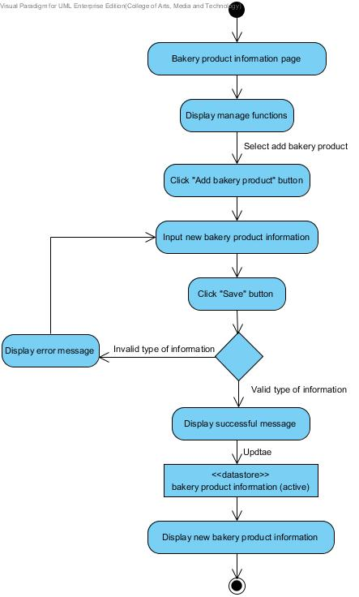

**Figure 9: AD-08 Admin add bakery product information**

**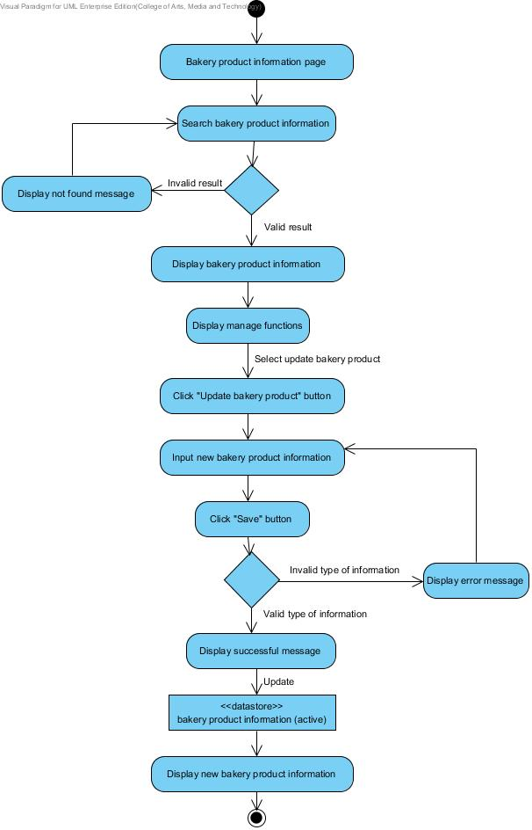**

**Figure 10: AD-09 Admin update bakery product information**

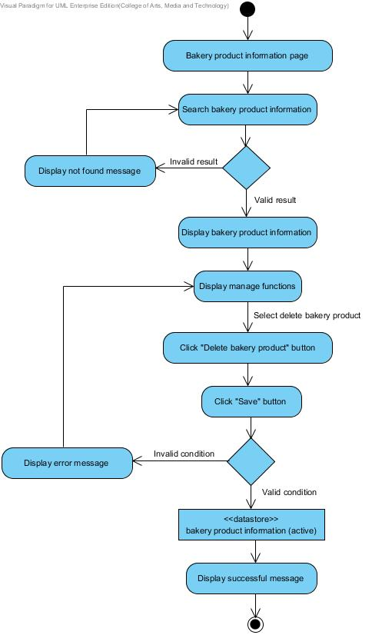

**Figure 11: AD-10 Admin delete bakery product information**

**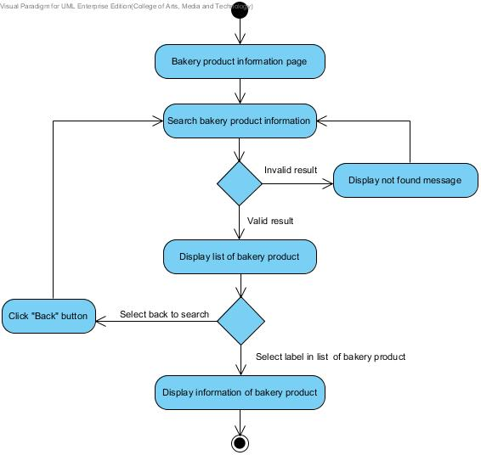**

**Figure 12: AD-11 Admin and wholesaler view bakery product information**

**Output:** Admin can manage bakery product information and all information of bakery product will record to the database and.

**System Requirement Specification:**

**SRS-01:** The system can connect to the database.

**SRS-25:** The system shall provide a link for creating new bakery product information within the bakery product interface.

**SRS-26:** The system shall provide a bakery product form within a creating new bakery product information page interface to admin input bakery product information.

**SRS-04:** The system shall provide service for validation input information.

**SRS-27:** The system shall provide notification to display a message after submitting bakery product form.

**SRS-06:** The system shall provide service to store information into the database.

**SRS-28:** The system shall provide a textbox within bakery product interface to search the bakery product information.

**SRS-29:** The system shall provide a user interface to display all list of bakery product. In each label shall display bakery product name text and bakery product picture on bakery product list.

**SRS-30:** The system shall provide a user interface to display the old bakery product information which are bakery product ID, bakery product name, product description, product price, product category and product picture on view information of bakery product page.

**SRS-31:** The system shall provide a link for update bakery product information within the bakery product interface.

**SRS-32:** The system shall provide a bakery product form within updating bakery product information page interface to admin update new bakery product information.

**SRS-33:** The system shall provide service to update bakery product information into the database.

**SRS-34:** The system shall provide a user interface to display the new bakery product information.

**SRS-35:** The system shall provide service to get new bakery product information to display in bakery product interface.

**SRS-36:** The system shall provide a link for delete bakery product information within the bakery product interface.

**SRS-14:** The system shall provide confirmation dialog box.

**SRS-37:** The system shall provide service to delete bakery product information into the database

**URS-06:** Wholesaler can view all bakery product information by search keyword

of bakery product ID, bakery product name, information, price, category and product picture in the database.

**Precondition:** The wholesaler must have login to the system.

**Input:** -

**Action:**

****

**Figure 12: AD-11 Admin and wholesaler view bakery product information**

**Output:** Wholesaler can view bakery product information in the database.

**System Requirement Specification:**

**SRS-01:** The system can connect to the database.

**SRS-28:** The system shall provide a textbox within bakery product interface to search the bakery product information.

**SRS-04:** The system shall provide service for validation input information.

**SRS-29:** The system shall provide a user interface to display all list of bakery product. In each label shall display bakery product name text and bakery product picture on bakery product list.

**SRS-30:** The system shall provide a user interface to display the old bakery product information which are bakery product ID, bakery product name, product description, product price, product category and product picture on view information of bakery product page.